Technology Task – Social Bookmarking

1. Open a Firefox or Internet Explorer Web browser.

2. In the URL box, www.delicious.com and hit enter. Click on Join Now or Sign In if you are already a member.
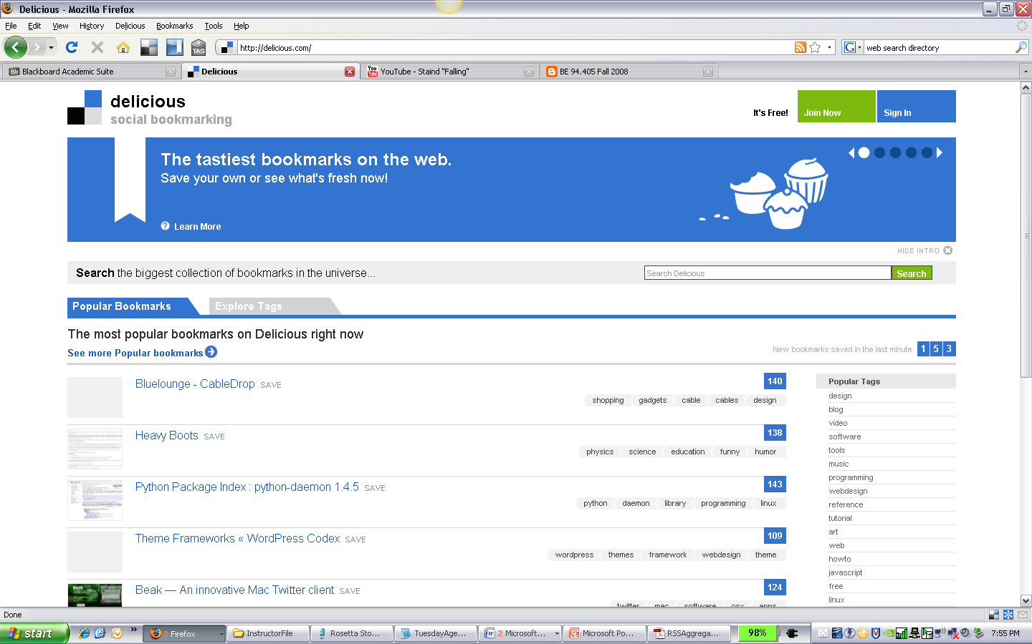

3. Complete the textboxes, Agree to the Terms, and click on Register.
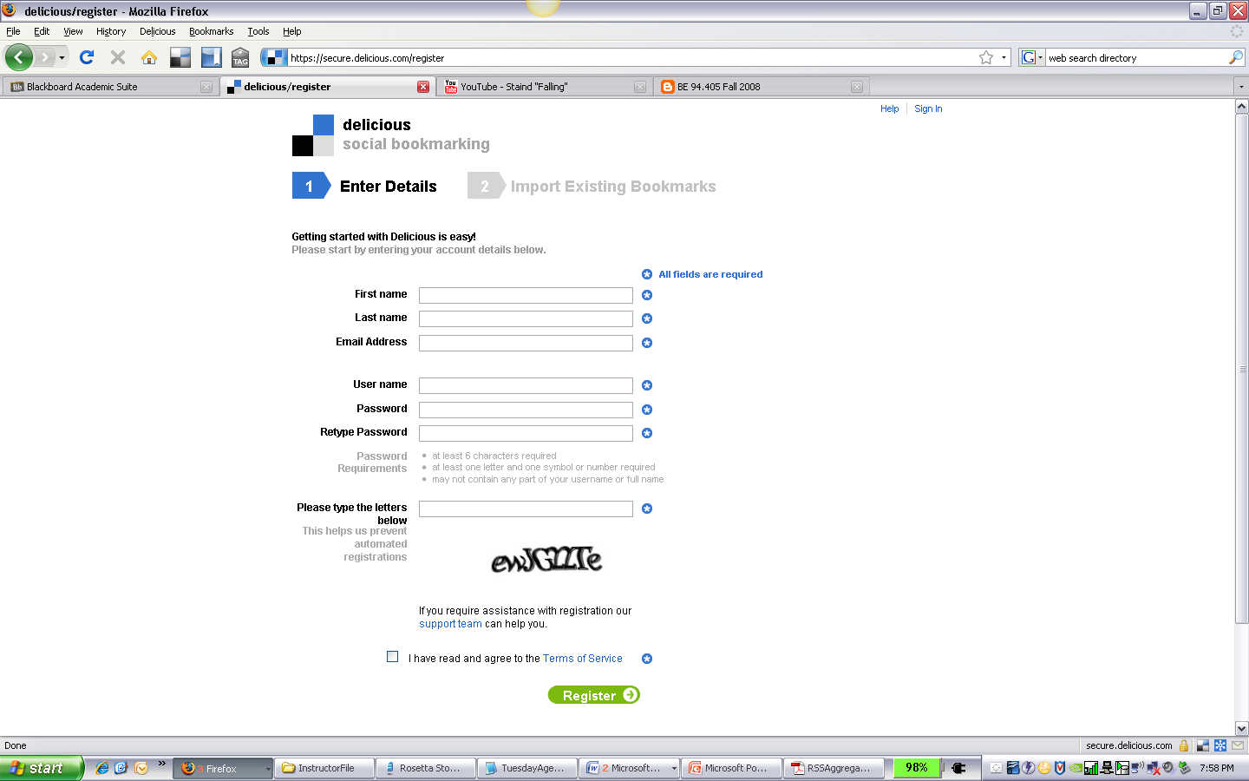

4. Import your existing bookmarks from your web browser. If you do not want to import, deselect the option buttons. Click on Import Now.

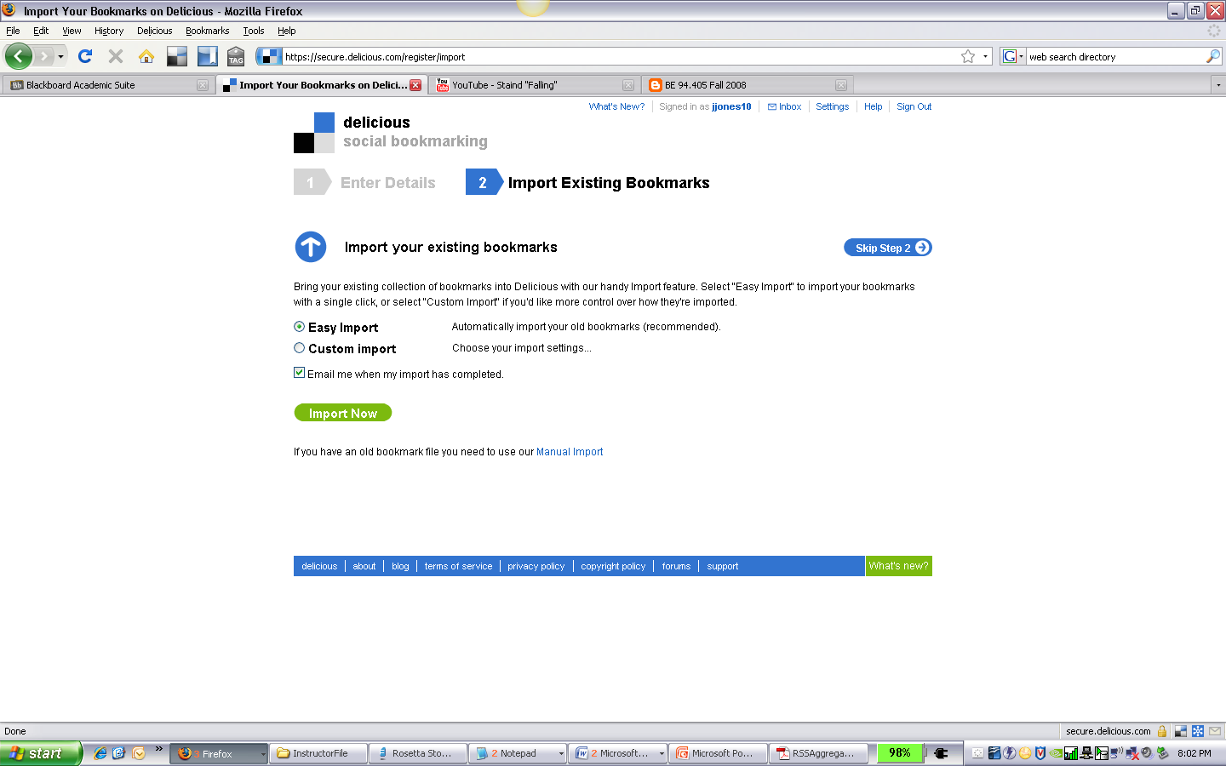

5. You are now ready to begin using Delicious social bookmarking.
